Cloud Basics Assignment

Question 1:
A)Create a private subnet inside the pre-created VPC, using the CIDR
Pre created VPC
VPC ID
vpc-0b7394ff5e320ea55
IPv4 CIDR
172.31.0.0/16
Subnet Name== > hu-spark-26-Saharsh-private-subnet
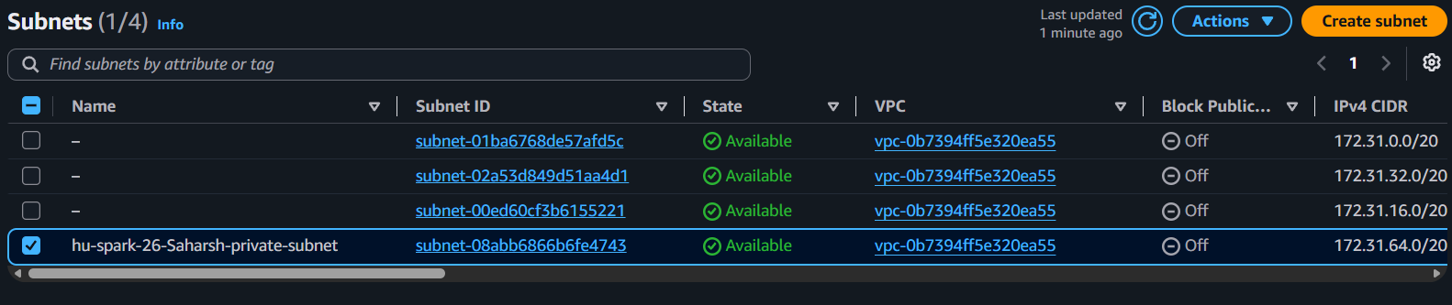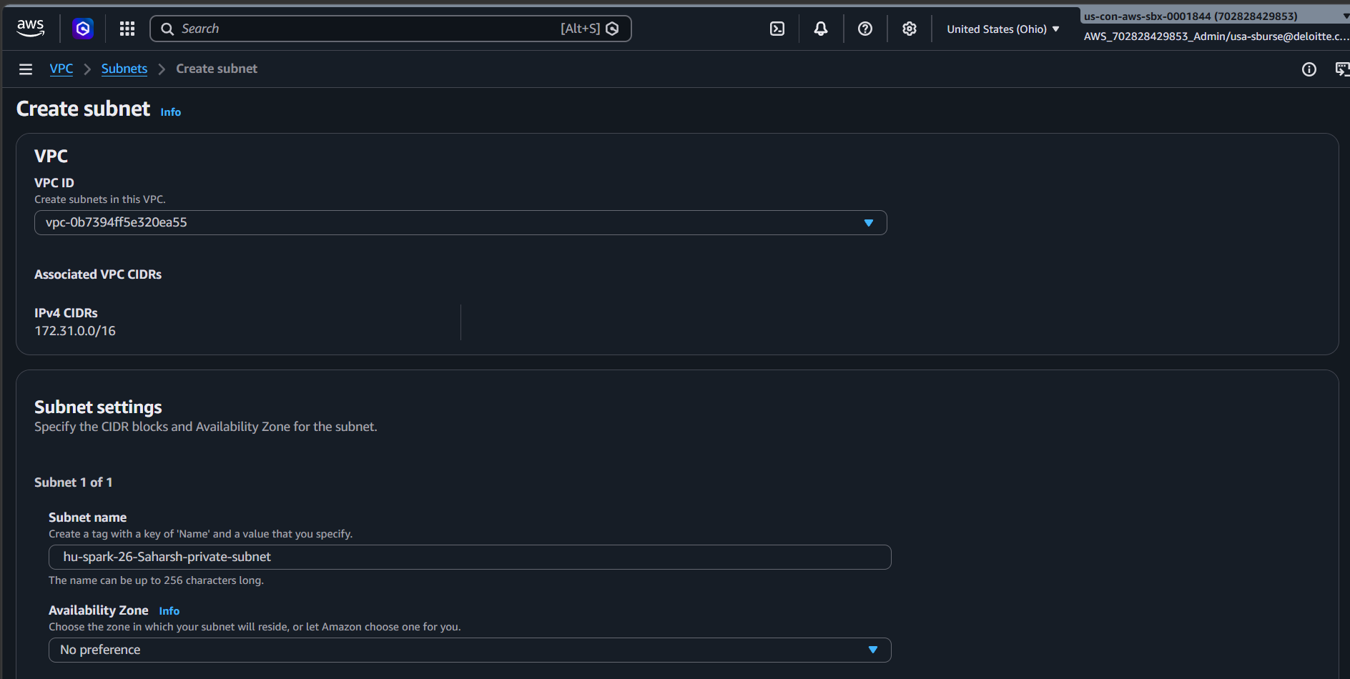

B) Create a NAT Gateway and update your subnet's route table so 0.0.0.0/0 routes through it — this gives outbound-only internet access for package installs; nothing can initiate a connection in.
Name= hu-spark-26-Saharsh-nat-gateway
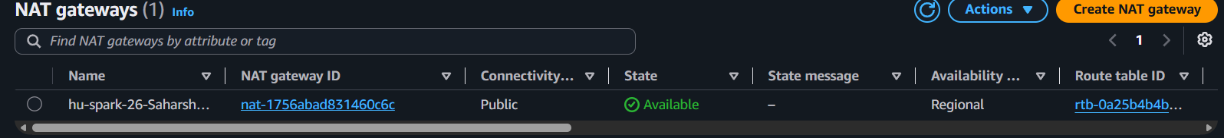
route Table = hu-spark-26-Saharsh-private-route-table
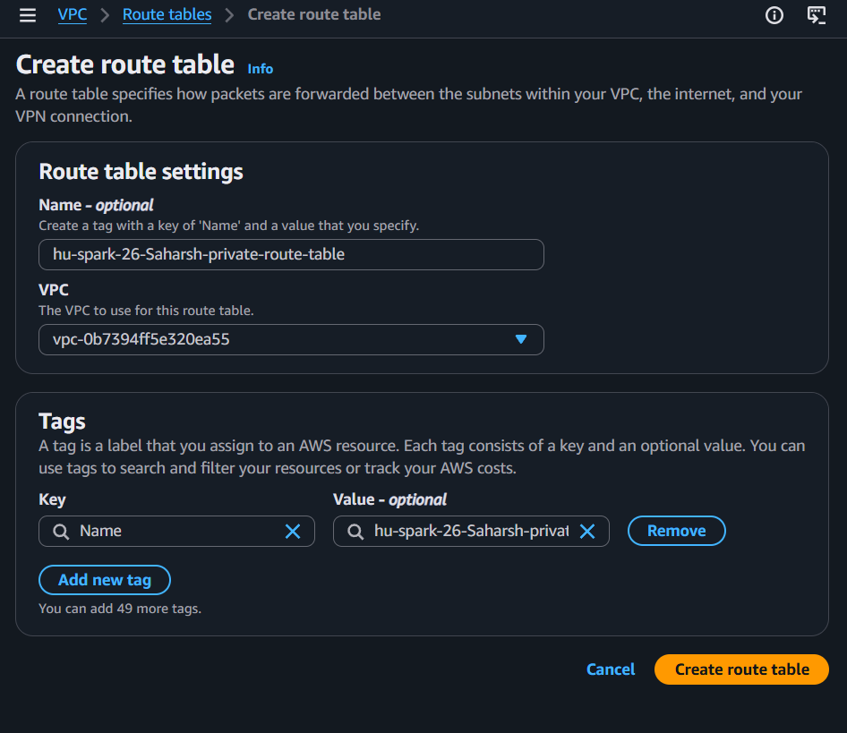

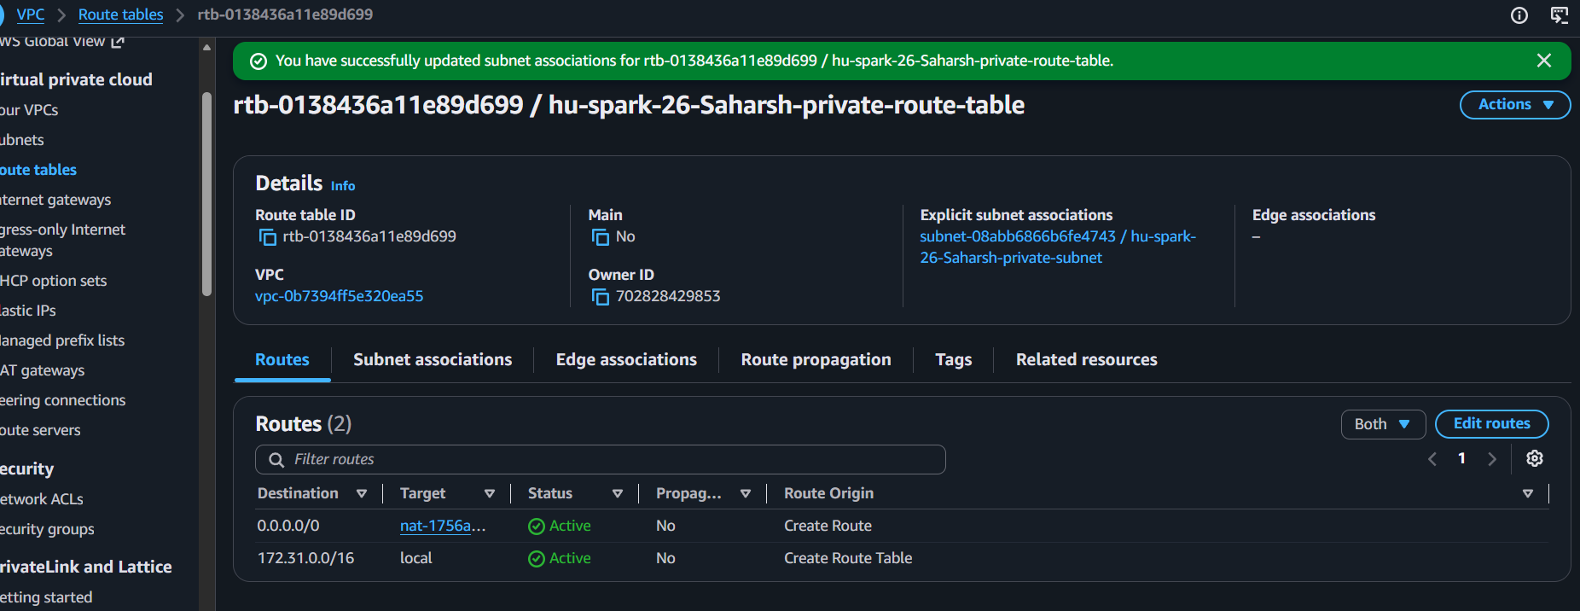
C) Create a Security Group: inbound HTTP (80) from the VPC CIDR only. No SSH inbound rule — management goes through Session Manager, not the network.
hu-spark-26-Saharsh-web-sg
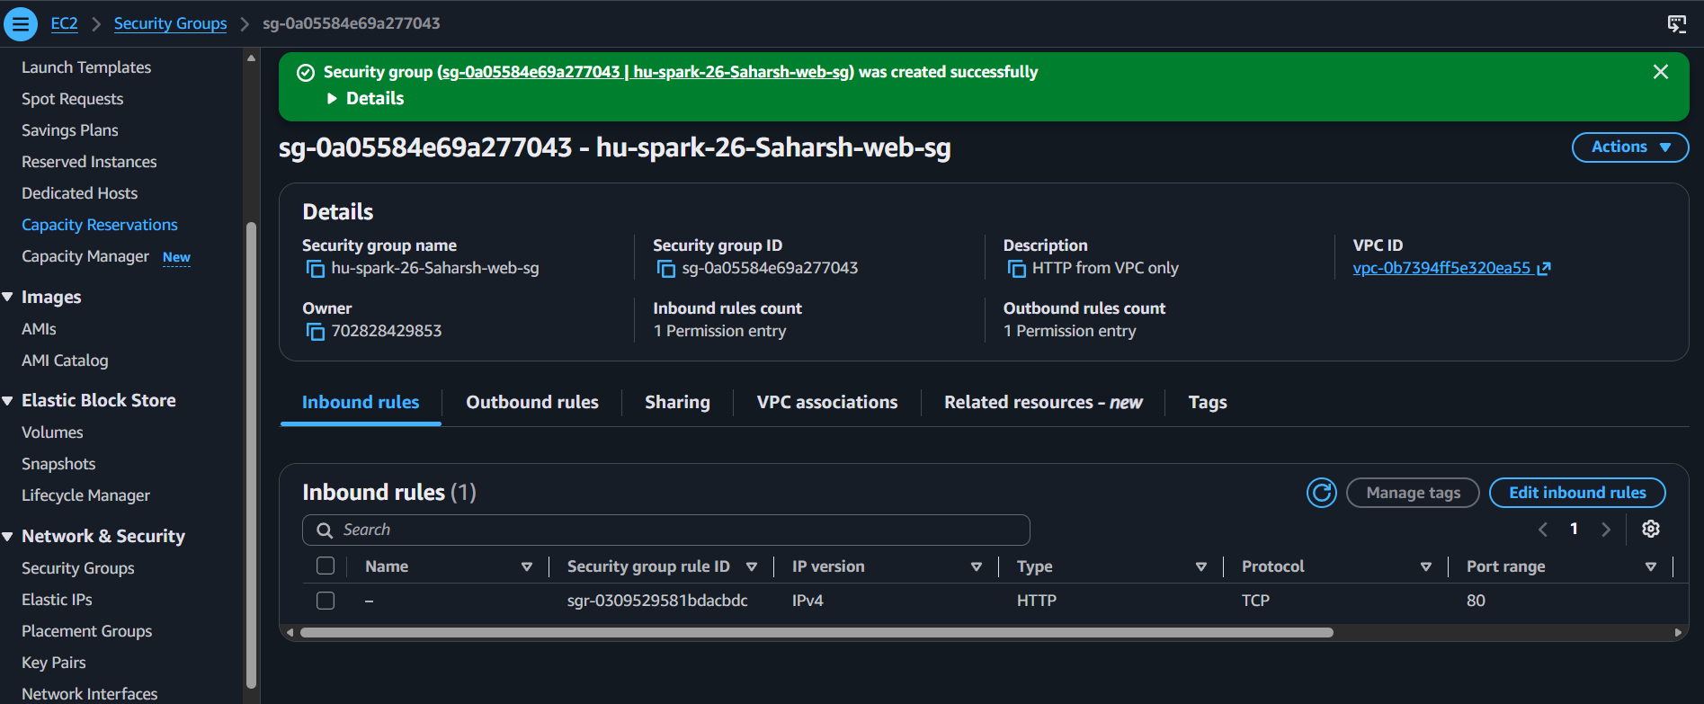
D) Create an IAM Role with S3 read-only access plus the AmazonSSMManagedInstanceCore policy (enables Session Manager), with an EC2 trust relationship.
hu-spark-26-Saharsh-ec2-role

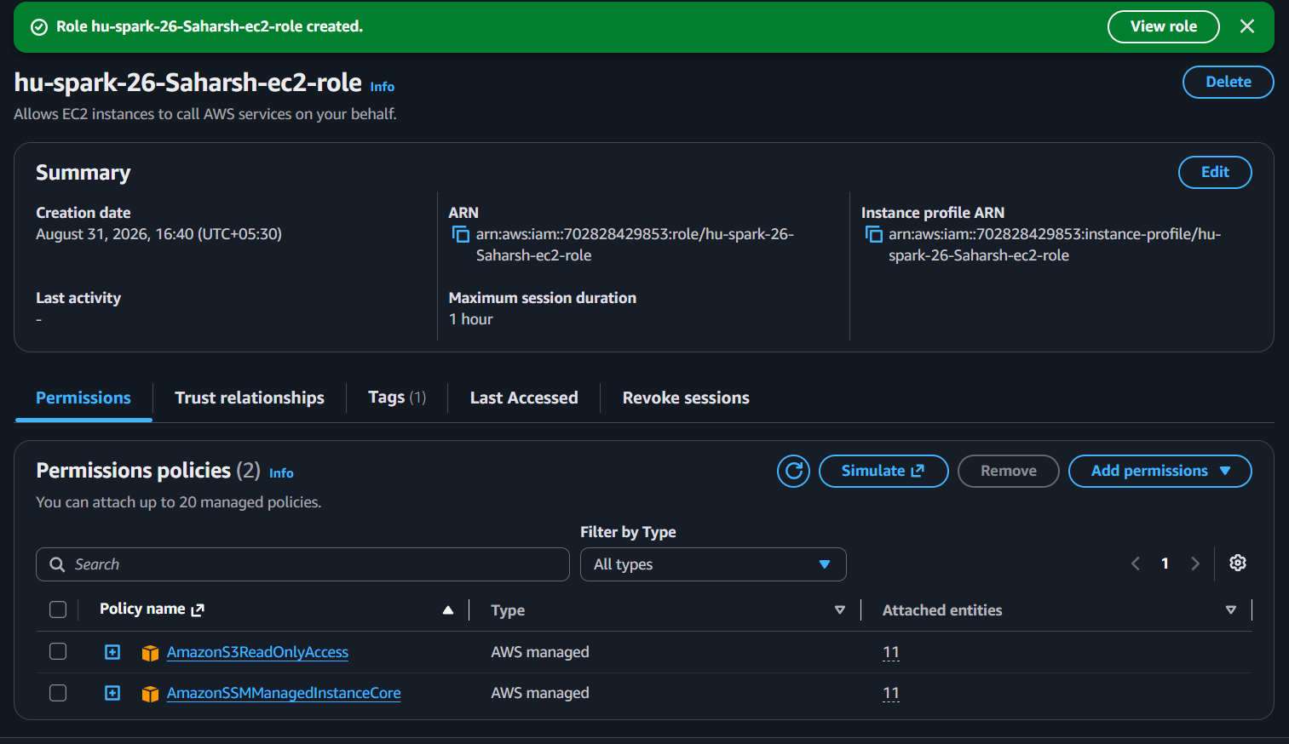
E) Launch a t2.micro/t3.micro EC2 instance into your subnet, explicitly assigning it the private IP address, with "Auto-assign public IP" disabled.
EC2 instance Name =hu-spark-26-Saharsh-apache-server
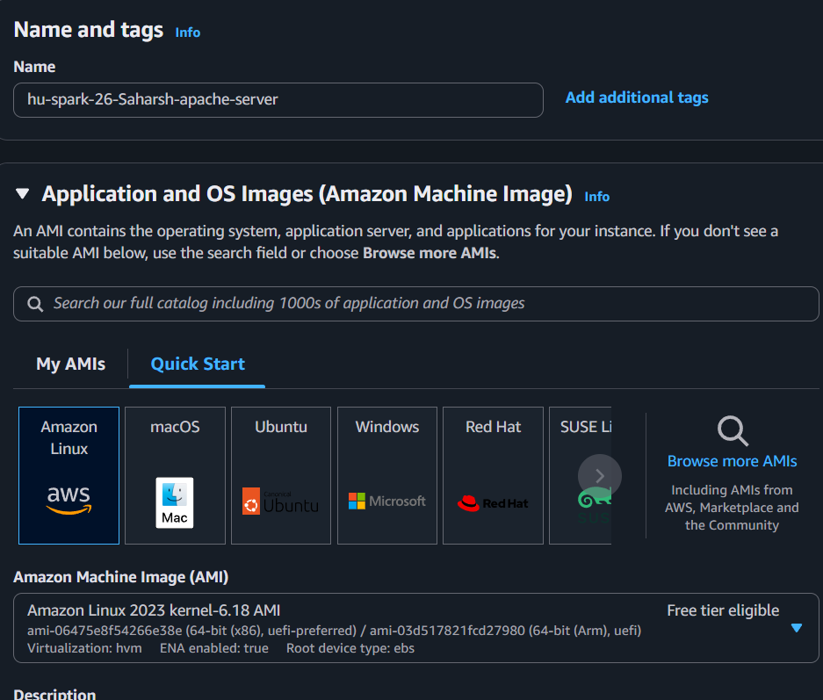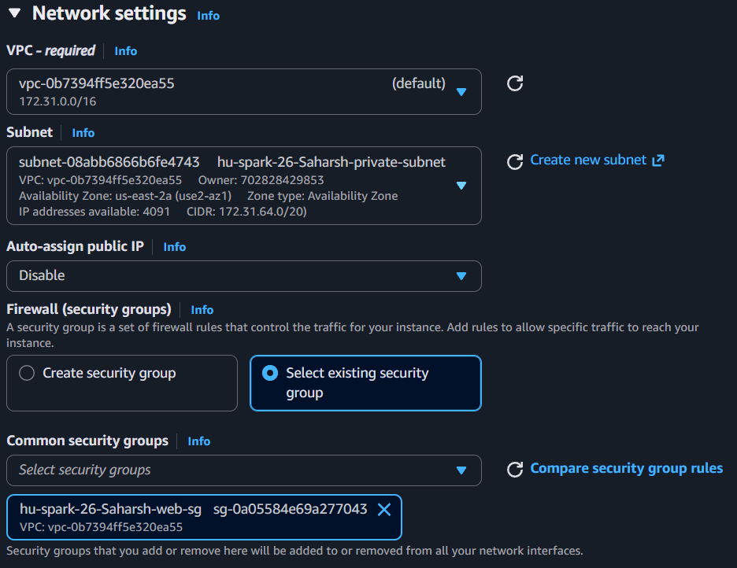

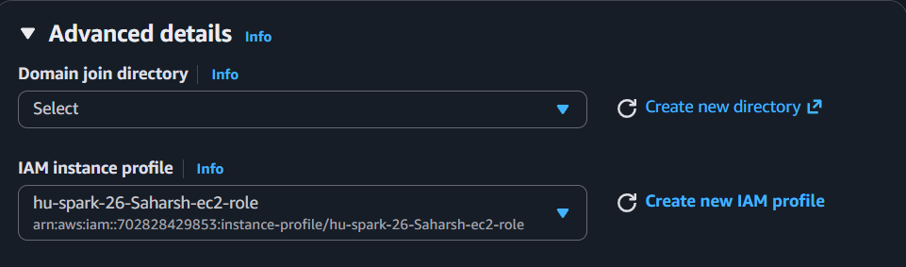

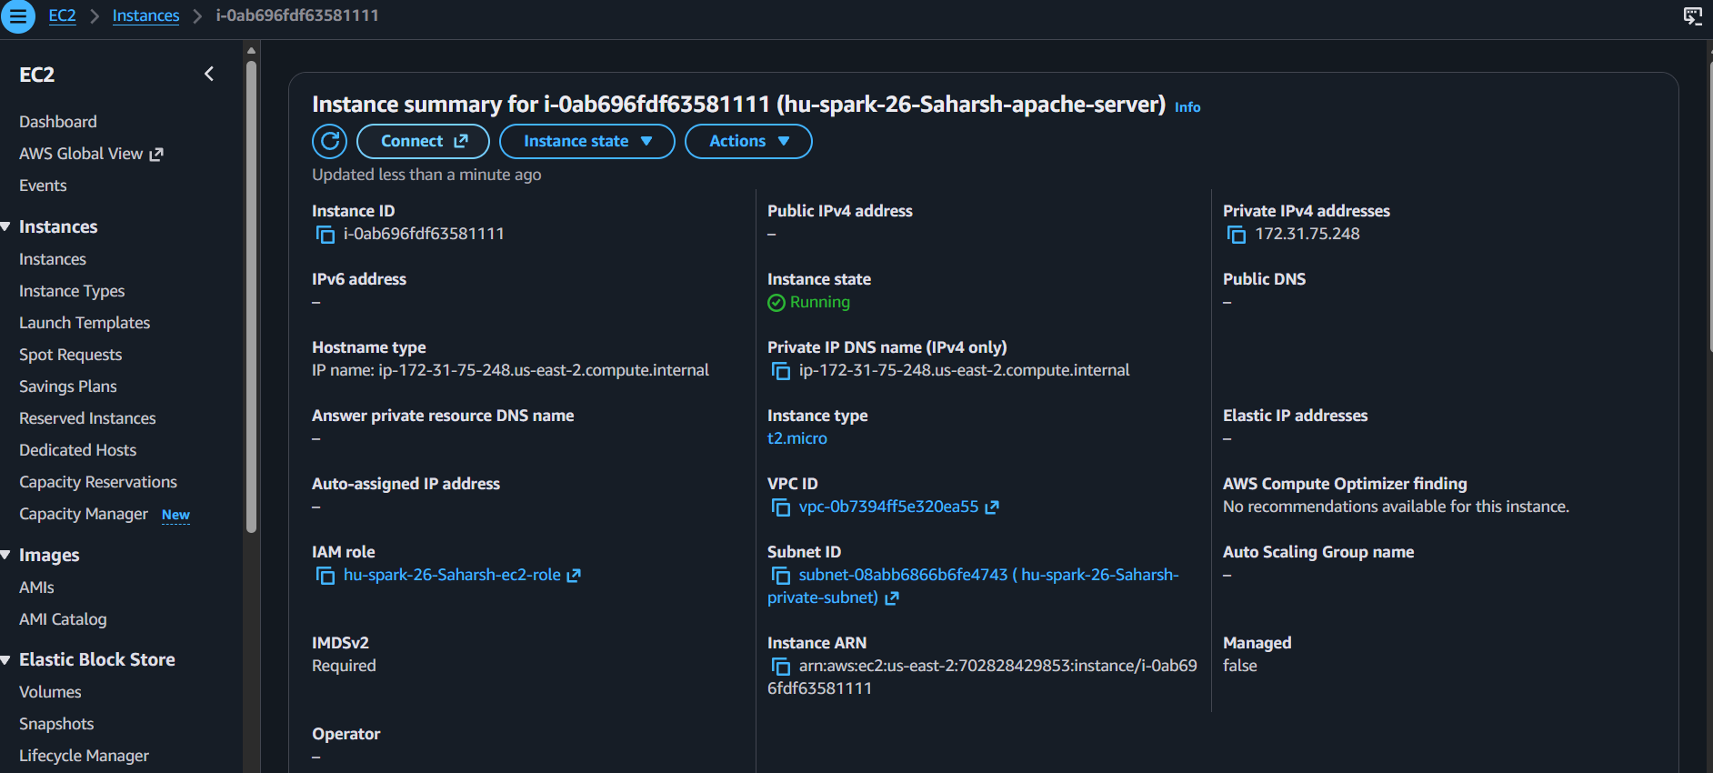
F) From that session, start an SSM port-forwarding session (or use another host inside the VPC) to browse to http://<your-private-ip> and confirm the page loads over the network.

Question 2:
- Design a small static site (a portfolio or landing page) — plain HTML/CSS, at least two pages or sections.
- Create an S3 bucket with a unique name, prefixed with your name, and enable static website hosting.
Name saharsh-aws-s3-bucket-private-portfolio
hu-spark-26-saharsh-portfolio-endpoint

